**Title: Homicides increase variation on lifespans in Mexico and its States, 2005-2015 [intended for Demography] [Second PDR] [or a health journal]**

**Authors:** José Manuel Aburtoa & Hiram Beltrán-Sánchezb

**Author affiliations:**

a University of Southern Denmark, Odense 5000, Denmark.

b Department of Community Health Sciences at the Fielding School of Public Health and California Center for Population Research, Center for Health Sciences, Los Angeles, California, USA.

**Corresponding author:**

José Manuel Aburto

Email: [jmaburto@health.sdu.dk](mailto:jmaburto@health.sdu.dk)

Tel. number: +45 65 50 94 16

Affiliation: EBB/Epidemiology, Biostatistics and Biodemography; University of Southern Denmark.

Address: J.B. Winsløws Vej 9. DK-5000 Odense C, Denmark

**Classification:** Violence, Population Health and Demography

**Keywords:** violence, homicide, lifespan variation, life expectancy, demography.

**Abstract [Max 250 words]:**

**\maintext[max 8000 words]**

**Introduction**

Violence is a main public health issue in Latin America since the end of the 20th century [1]. This region experiences the highest homicide rate in the world (over 16.3 per 100,000 people), and a set of countries in Central America, including Mexico, have undergone an upsurge of homicide mortality in the first years of the 21st century [2]. In Mexico, homicide rates doubled between 2007 and 2012 (from 9.3 to 18.6) [3]. As a result of this increase, along with the burden of diabetes, male life expectancy in Mexico stagnated in the period 2000-10 [4]. At the subnational level, evidence indicates that gains in life expectancy due to causes amenable to medical service throughout 2000-10, such as infectious and respiratory diseases and birth conditions, were wiped out by the increase of homicide and diabetes mortality in each of the 32 states in Mexico, albeit with large regional variations [5].

Trends in life expectancy are important and have been studied in Mexico and its states [4-6]. However, life expectancy masks substantial heterogeneity in individual mortality trajectories [7, 8], referred here as lifespan variation. This age-at-death variation expresses a fundamental inequality between individuals [9], and it has arisen as an important topic since it addresses the growing interest in health inequalities [10]. Studying both life expectancy and lifespan variation is important because individuals take decisions based not only on their expected lifetime, but also on the uncertainty in their timing of death [11]. Most studies have found a negative association between these two measures, suggesting that as life expectancy increases, variation in lifespans decreases [8, 12-14]. However, at the subnational level some evidence suggest that increases in variation occur with simultaneous increases in life expectancy, mostly due to a slowdown in mortality improvements in working ages [15, 16]. In Mexico, homicide mortality is concentrated between ages 15 and 50, affecting mainly males. In addition, there exist large inequalities in epidemiological profiles between states in the country [6]. Therefore, it is possible that the upsurge of homicides in the country have had a large impact on lifespan variation at the population level, but also the effect might be uneven across the country. To date, no comprehensive study of lifespan variation has focus on the effect of the sharp increase in homicide mortality under periods of life expectancy decline or stagnation.

In this study, we focus in the Mexican case, which shows substantial mortality fluctuations and large regional variation. Given the unexpected rise in homicide mortality after 2005 that have disproportionally affected the young population and the increasing burden of diabetes mortality among adults in the new century, along with improvements in mortality due to medically amenable conditions and other causes of death, it is imperative to measure their effect on the variability of age at death in the Mexican population. For instance, states in the Northern part of the country (e.g., Chihuahua, Durango and Sinaloa) that experienced the largest losses in life expectancy due to homicides between 2005-10 [5] may also exhibit the largest effect on lifespan variation in the country, although in recent years this impact may be larger in other states as homicides spread throughout the entire country [17]. However, since the more pronounced fluctuation in age-specific mortality occurred over working ages [5], it is unclear what the net effect would be on lifespan variation but it certainly had an effect on premature mortality. On the other hand, there have been mortality improvements in the country particularly at younger ages which have been a priority in the country since the 1990s (e.g., birth-related conditions) [18, 19]. These improvements could have a substantial effect on reducing variation in lifespans, particularly in historically poor states, which are mostly concentrated in the South. In this article we use $e^{†}$ as a measure of lifespan variation [20] since it allows us to analyze thoroughly premature mortality, and it has an important public health interpretation since it quantifies the average life expectancy losses attributable to death [21] . Thus, we analyzed how lifespan variation changed over a 20-year period, from 1995 to 2015, for females and males in Mexico and its 32 states, and determined the ages and causes of death that contributed the most to the observed change in life expectancy and lifespan variation.

**Study data and Methods**

Data on deaths from vital statistics files publicly available through the Mexican National Institute of Statistics and Geography were used [22]. These data include information on cause of death by age at the time of death, sex, and place of occurrence from 1995 to 2015. Additionally, we used population estimates corrected for completeness, age misstatement, and international migration available from the Mexican Population Council to construct age-specific death rates by sex and state [waiting for the period 2010-15, now these years are projections] [23].

***Cause-of-death classification***

We classified deaths into eight categories according to previous studies targeting the main causes of death in Mexico [5, 24] using the concept of amenable/avoidable mortality [25, 26]. This concept assumes that there are some conditions that should not cause death in presence of timely and effective medical care. Deaths due to these conditions are a proxy of the performance of health care systems [25].

The first category includes conditions amenable to medical service. It refers to mortality that could be reduced by primary or secondary prevention, and timely medical care (for example, birth conditions, infectious and respiratory diseases). We analyzed separately homicide, diabetes, ischemic heart diseases (IHD), lung cancer, cirrhosis, and road traffic accidents because the first two are leading causes of death in Mexico [4], and all of them are amenable to health behavior and medical service [5]. The eighth category includes the rest of causes of death labeled ‘Rest’. For details on the International Classification of Diseases [ICD] codes for each cause see the Supplemental file.

Originally, data on deaths were classified with the International Classification of Diseases (ICD), revision 9 for years 1995-1997 and revision 10 for 1998-2015. Previous studies have checked the validity of the cause-of-death codes used in this paper and did not find cause-specific ruptures in the transition from ICD 9 to ICD 10 [reference]. In addition, to mitigate biased interpretations we focus on causes of death below age 85 since coding practices above that age are less reliable due to the presence of comorbidities.

We broke down the period 1995-2015 into two comparable 10-year periods. That is, we studied changes in lifespan variation between 1995 and 2005, and from 2005 to 2015. This allowed us to identify a period of mortality improvements (1995-2005), during which life expectancy increased by 2.1 and 4.3 years for males and females respectively [23] and homicide rates fell down in young age groups [27]; and a period of life expectancy stagnation for males (around 72 years) and slow progress for females (from 76.7 to 77) alongside the unprecedented rise in homicide mortality [5].

***Dispersion measure***

Several dispersion measures have been proposed to analyze lifespan variability [8, 28]. In this study, we use $e^{†}$ as a dispersion indicator and we refer to it as “lifespan variation”. It is defined as the average remaining life expectancy when death occurs, or life years lost due to death [13, 20]. For example, if a cohort of newborns die at the same age then the value of $e^{†}$ is zero; while when death is very variable, people will die before their expected lifetime, contributing lost years to life disparity. In lifetable notation, it is defined as:

$e^{†}= -\int_{0}^{ω}{l\left(x\right)\text{μ(}x)e\text{(}x)\text{d}x}=-\int_{0}^{ω}{l\left(x\right)\text{ ln}l\left(x\right)\text{d}x}$.

where $l\left(x\right)\text{, } \text{μ(}x), e\text{(}x)$ and $ω$ are the survival function, the force of mortality, life expectancy at age $x$, and the open-aged interval, respectively. This indicator was chosen because it has an easy to understand interpretation and it is also easy to decompose allowing us to quantify the impact of age and cause-specific mortality on changes in life disparity over time [21, 29]. . An additional advantage is the high correlation between $e^{†}$ and other measures of variability in ages at death (e.g., life table entropy, coefficient of variation, or the Gini coefficient) which suggests that our main results would be very similar to those obtained with any of these additional measures [28].

***Demographic and statistical methods***

To mitigate random variations in cause-of-death classification, we smoothed cause-specific death rates over age using a 1-d p-spline separately by year, sex and state [30]. We then rescaled the smoothed cause-specific deaths to all-cause death rates to maintain the overall mortality level by year, sex, and state. Using these mortality rates we computed period life tables for males and females for each year-state in the study period (1995 to 2015) following standard demographic methods [31]. Finally, we computed life expectancies (e0) and life disparities for each year and estimated the age- and cause-specific contributions to the difference in them between the periods 1995-2005 and 2005-2015, using standard decomposition techniques [32]. All the analyses were carried out using R [33] and are fully reproducible from the Supplemental file. In addition, to analyze state-specific mortality profiles and changes along other period from 1995 to 2015 we created an interactive app to perform sensitivity analyzes available [here](https://goo.gl/H1y1R6).

**Results**

Figures 1 and 2 show age and cause contributions to the change in Mexican life expectancy at birth and lifespan variation for males, respectively. Panels A refer to the change between 1995 and 2005, and panels B present the changes from 2005 to 2015[1]. Between 1995 and 2005, there was an increase of two years in life expectancy for males (from 69.2 to 71.2), while women experienced an increase of 1.3 years, changing from 75.4 to 76.7. The progress made in reducing perinatal conditions and ages below age 5 is equivalent to three quarters of a year of increase in life expectancy for both males and females. Over the full age span, reductions in mortality from conditions amenable to medical service (AMS) (blue bars) and homicides (red) account for more than one and a half years of increase in life expectancy for males and over one full year in females between 1995 and 2005. Opposing this, diabetes and ischemic heart diseases (IHD) caused a reduction of over half a year in the same period, mainly in ages above 40 in both sexes.

From 2005 to 2015 (Figure 1B), the progress in increasing life expectancy was slowed down by half for males, increasing half of what they improved in the decade before, while female life expectancy increased an additional year. Homicides contributed the most to the slowdown in life expectancy (-0.3 years), mostly between ages 15 and 60. Diabetes and IHD continued to deteriorate, bringing down life expectancy by 0.26 years in males and 0.15 in females. In males, progress in reducing deaths from lung cancer and cirrhosis contributed to the rise in life expectancy. Conditions amenable to medical service continued increasing life expectancy, albeit at a slower pace than ten years before.

[Figure 1 about here]

Lifespan variation ($e^{†}$) decreased throughout the entire period 1995-2015 for males and females at the national level. However, stronger reductions on $e^{†}$ were made between 1995 and 2005 changing from 16.5 to 15.3 for males, and from 14.3 to 13.4 years for females. In the following ten years, 2005-2015, reductions represented almost half of the improvements made in the previous period (1995-2005). Homicides and conditionals amenable to medical service account for most of the decrease in $e^{†}$ between 1995 and 2005 for males, -0.24 and -0.61 years respectively. Diabetes, contributed negatively to the change in lifespan variation, mainly because of mortality deterioration above age 70 in both males and females. Like males, most reduction on $e^{†}$ were caused by medically amenable conditions.

Between 2005 and 2015, the increase in homicide mortality had a positive impact on lifespan variation of 0.16 years in ages below age 60 for males, and a negligible impact for females. Opposing this, improvements in mortality in road traffic accidents (-0.11) and cirrhosis (-0.11) decreased variation in lifespans. Importantly, deteriorations in diabetes mortality in ages above 70 continued helping reducing lifespan variation.

[Figure 1 about here]

**Changes in life expectancy and lifespan variation at the national level**

**Changes and cause-specific contributions to life expectancy and lifespan variation at state level**

**Discussion**

**Funding**

**References**

1. Briceño-León, R., A. Villaveces, and A. Concha-Eastman, *Understanding the uneven distribution of the incidence of homicide in Latin America.* International Journal of Epidemiology, 2008. **37**(4): p. 751-757.

2. Drugs, U.N.O.o. and Crime, *Global study on homicide 2013: trends, contexts, data*. 2013: UNODC.

3. Gamlin, J., *Violence and homicide in Mexico: a global health issue.* The Lancet, 2015. **385**(9968): p. 605-606.

4. Canudas-Romo, V., V.M. García-Guerrero, and C.J. Echarri-Cánovas, *The stagnation of the Mexican male life expectancy in the first decade of the 21st century: the impact of homicides and diabetes mellitus.* J Epidemiol Community Health, 2015. **69**(1): p. 28-34.

5. Aburto, J.M., et al., *Homicides in Mexico reversed life expectancy gains for men and slowed them for women, 2000–10.* Health Affairs, 2016. **35**(1): p. 88-95.

6. Gómez-Dantés, H., et al., *Dissonant health transition in the states of Mexico, 1990–2013: a systematic analysis for the Global Burden of Disease Study 2013.* The Lancet, 2016. **388**(10058): p. 2386-2402.

7. Edwards, R.D. and S. Tuljapurkar, *Inequality in life spans and a new perspective on mortality convergence across industrialized countries.* Population and Development Review, 2005. **31**(4): p. 645-674.

8. Wilmoth, J.R. and S. Horiuchi, *Rectangularization revisited: Variability of age at death within human populations*.* Demography, 1999. **36**(4): p. 475-495.

9. Tuljapurkar, S., *The final inequality: variance in age at death*, in *Demography and the Economy*. 2010, University of Chicago Press. p. 209-221.

10. Marmot, M., *Inequalities in health.* New England Journal of Medicine, 2001. **345**(2): p. 134-135.

11. van Raalte, A.A., et al., *More variation in lifespan in lower educated groups: evidence from 10 European countries.* International Journal of Epidemiology, 2011: p. dyr146.

12. Engelman, M., V. Canudas-Romo, and E.M. Agree, *The implications of increased survivorship for mortality variation in aging populations.* Population and Development Review, 2010. **36**(3): p. 511-539.

13. Vaupel, J.W., Z. Zhang, and A.A. van Raalte, *Life expectancy and disparity: an international comparison of life table data.* BMJ open, 2011. **1**(1): p. e000128.

14. Colchero, F., et al., *The emergence of longevous populations.* Proceedings of the National Academy of Sciences, 2016. **N.A**(N.A): p. N.A.

15. Sasson, I., *Trends in life expectancy and lifespan variation by educational attainment: United States, 1990–2010.* Demography, 2016. **53**(2): p. 269-293.

16. van Raalte, A.A., P. Martikainen, and M. Myrskylä, *Lifespan variation by occupational class: compression or stagnation over time?* Demography, 2014. **51**(1): p. 73-95.

17. Espinal-Enríquez, J. and H. Larralde, *Analysis of México’s Narco-War Network (2007–2011).* PloS one, 2015. **10**(5): p. e0126503.

18. González-Pier, E., et al., *Mexico's path towards the Sustainable Development Goal for health: an assessment of the feasibility of reducing premature mortality by 40% by 2030.* The Lancet Global Health, 2016. **4**(10): p. e714-e725.

19. Sepúlveda, J., et al., *Improvement of child survival in Mexico: the diagonal approach.* The Lancet, 2006. **368**(9551): p. 2017-2027.

20. Vaupel, J.W. and V. Canudas-Romo, *Decomposing change in life expectancy: A bouquet of formulas in honor of Nathan Keyfitz’s 90th birthday.* Demography, 2003. **40**(2): p. 201-216.

21. Shkolnikov, V.M., et al., *Losses of expected lifetime in the United States and other developed countries: methods and empirical analyses.* Demography, 2011. **48**(1): p. 211-239.

22. INEGI. *National Institute of Statistics: Micro-data files on mortality data 1995-2015*. 2017 [cited 2017 21/4/2017]; Available from: <http://www.beta.inegi.org.mx/proyectos/registros/vitales/mortalidad/default.html>.

23. CONAPO. *Mexican Population Council: Population estimates.* 2017 [cited 2017 21/4/2017]; Available from: <https://datos.gob.mx/busca/dataset/activity/proyecciones-de-la-poblacion-de-mexico>.

24. Franco-Marina, F., et al., *La mortalidad en México, 2000-2004. Muertes Evitables: magnitud, distribución y tendencias.* Dirección General de Información en Salud, Secretaría de Salud. México, 2006: p. 2.

25. Nolte, E. and C.M. McKee, *Measuring the health of nations: updating an earlier analysis.* Health affairs, 2008. **27**(1): p. 58-71.

26. Nolte, E. and M. McKee, *Measuring the health of nations: analysis of mortality amenable to health care.* Bmj, 2003. **327**(7424): p. 1129.

27. Frías, S.M. and D. Finkelhor, *Homicide of children and adolescents in Mexico (1990–2013).* International Journal of Comparative and Applied Criminal Justice, 2017: p. 1-17.

28. van Raalte, A.A. and H. Caswell, *Perturbation analysis of indices of lifespan variability.* Demography, 2013. **50**(5): p. 1615-1640.

29. Zhang, Z. and J.W. Vaupel, *The age separating early deaths from late deaths.* Demographic Research, 2009. **20**(29): p. 721-730.

30. Camarda, C.G., *MortalitySmooth: An R Package for Smoothing Poisson Counts with P-Splines.* Journal of Statistical Software, 2012. **50**: p. 1-24.

31. Preston, S.H., P. Heuveline, and M. Guillot, *Demography. Measuring and Modeling Population Processes*. 2001: Blackwell.

32. Horiuchi, S., J.R. Wilmoth, and S.D. Pletcher, *A decomposition method based on a model of continuous change.* Demography, 2008. **45**(4): p. 785-801.

33. Team R Core, *R: A language and environment for statistical computing.* 2013.

**Tables and Figures**

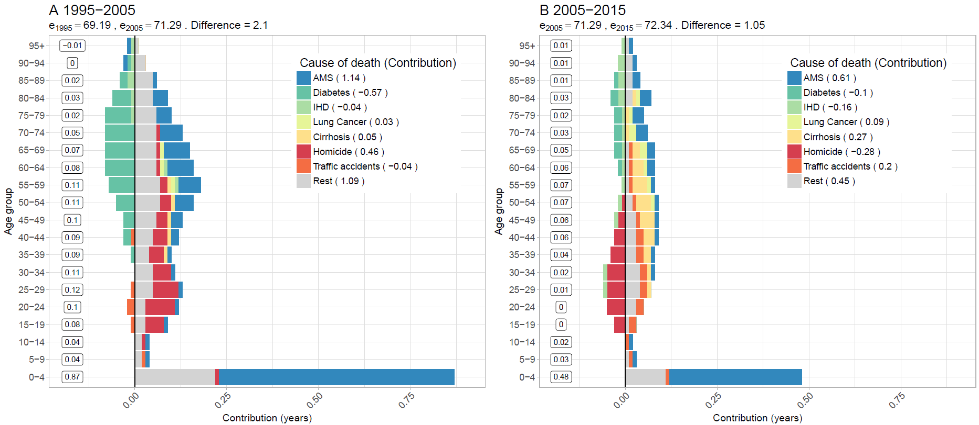**Figure 1. Age-cause specific contributions to the changes in national life expectancy (**e0**) for males. Panel A refers to 1995-2005 and panel B to 2005-2015. Note: Numbers in boxes are age-specific contributions.**

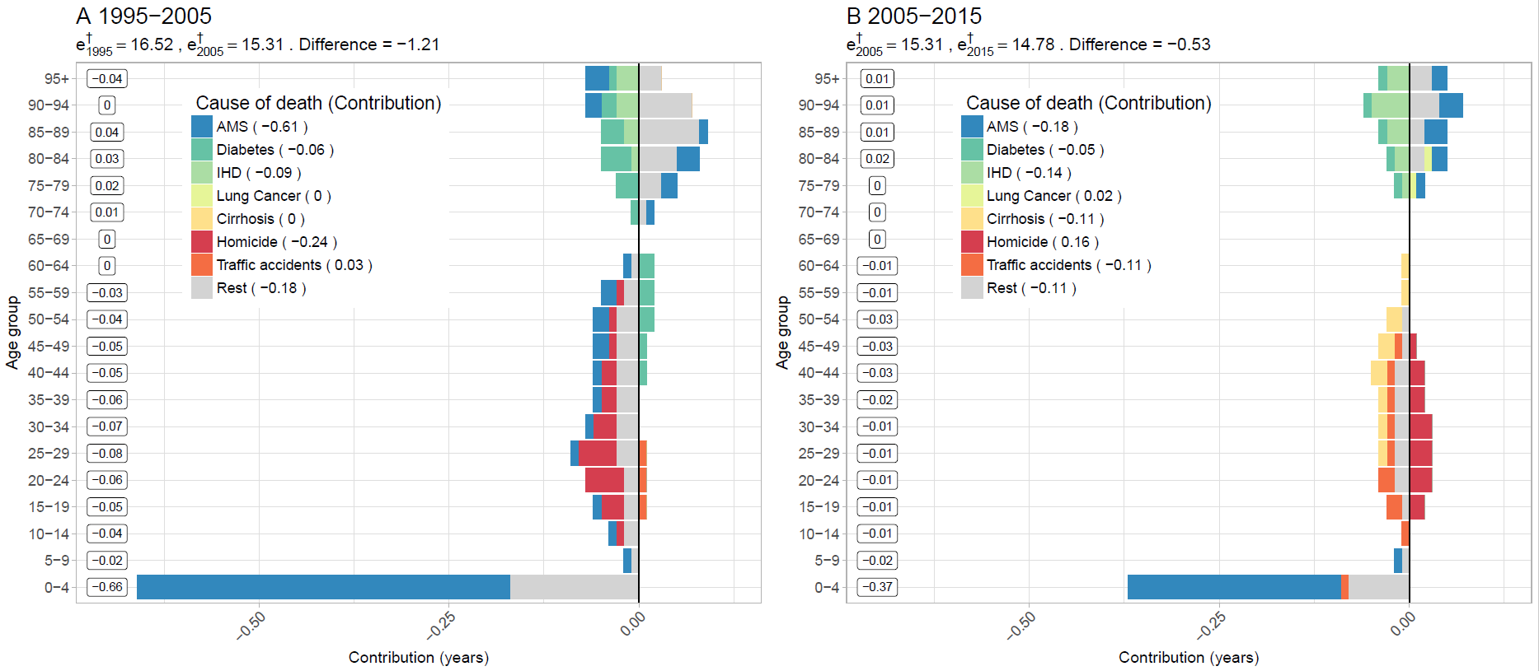**Figure 2. Age-cause specific contributions to the changes in national lifespan variation ($e^{†}$) for males. Panel A refers to 1995-2005 and panel B to 2005-2015. Note: Numbers in boxes are age-specific contributions.**

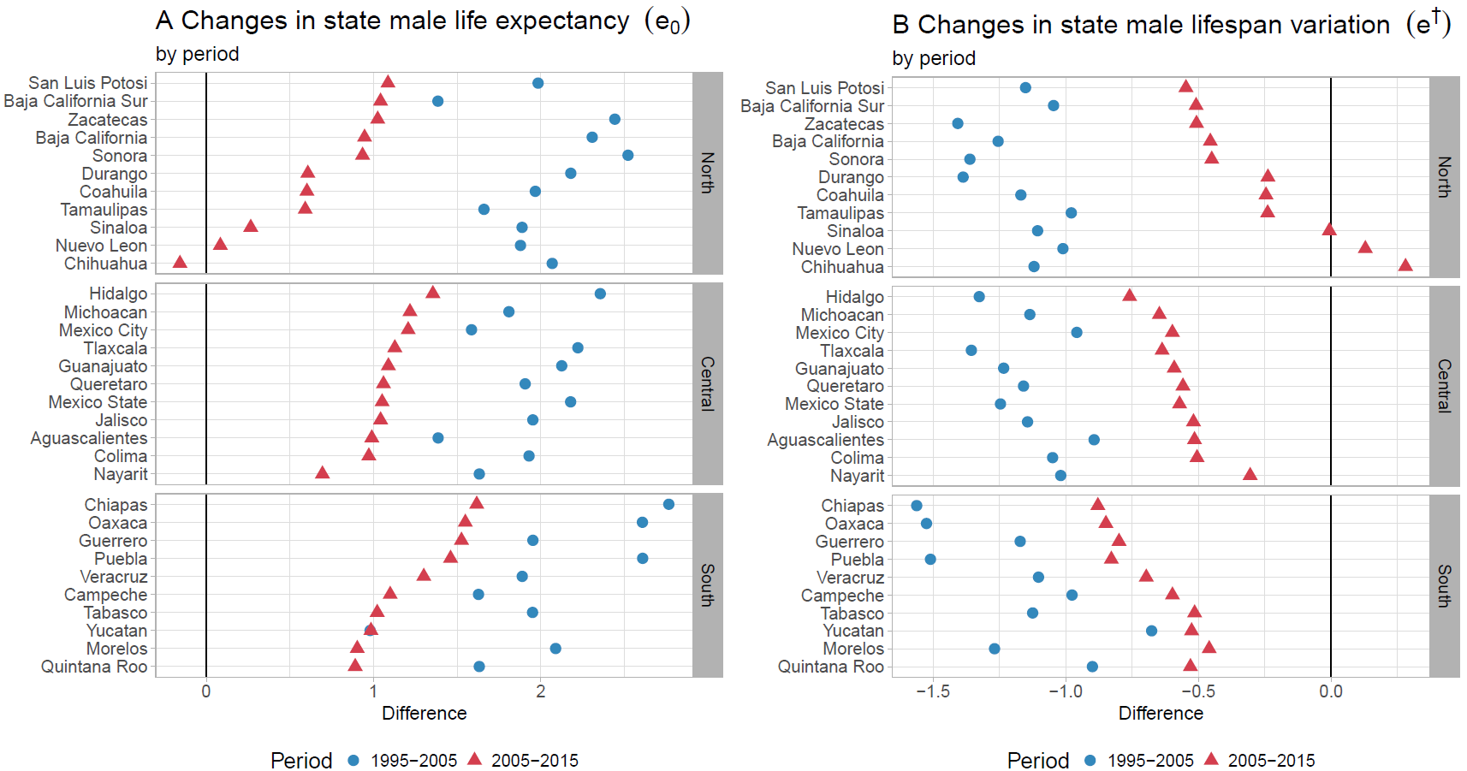**Figure 3. Changes in male life expectancy (**e0**) (panel A) and male lifespan variation ($e^{†}$) (panel B)**

**by state for the periods 1995-2005 and 2005-2015.**

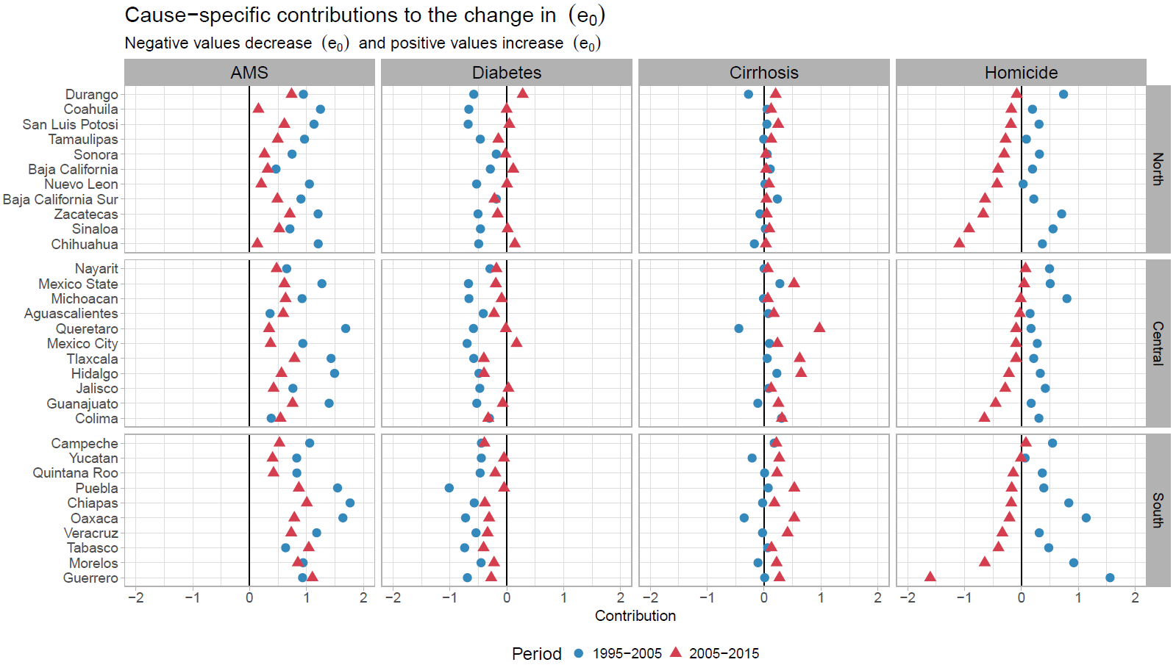**Figure 4. Cause-specific contributions to changes in male life expectancy by state for the periods 1995-2005 and 2005-2015.**

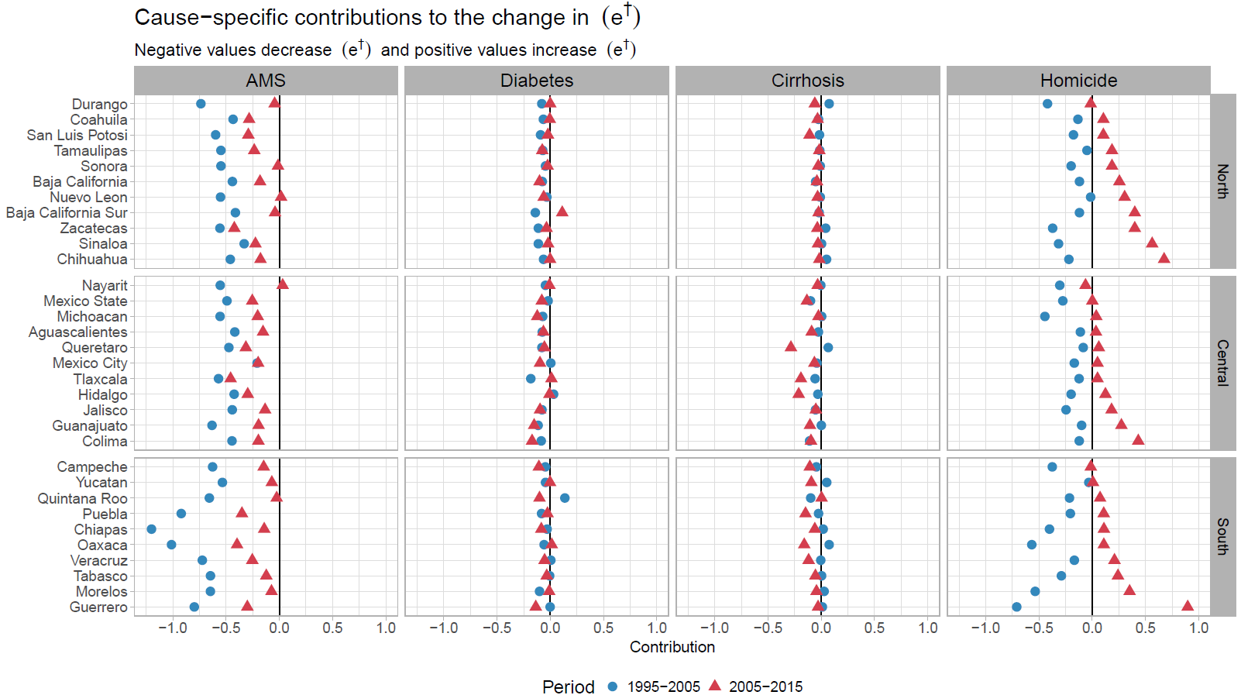**Figure 5. Cause-specific contributions to changes in male lifespan variation ($e^{†}$) by state for the periods 1995-2005 and 2005-2015.**

1. Results for females are available in the Supplementary Material Figures x and y.